**Arithmetic**

In this section, you'll learn about different types of Arithmetic operators in Python, their syntax and how to use them with examples.

Now you will ask me what is operators, ok so an operator is a symbol or function that indicates an operation. For example, in math, the plus sign or + is the operator that indicates addition. There are four main arithmetic operators in python.

* + (Addition)
* - (Subtraction)
* * (Multiplication)
* \ (Division)

In Python, Arithmetic operators perform just what they do in mathematics. In fact, you can use the Python programming language as a calculator.

Let's type the following commands in your Python file. You may edit the same file which you created before or create a new file as shown in the previous example.

To reopen an old file or create a new file the command is sudo nano filename.py and now we will write a Python program to print two numbers.

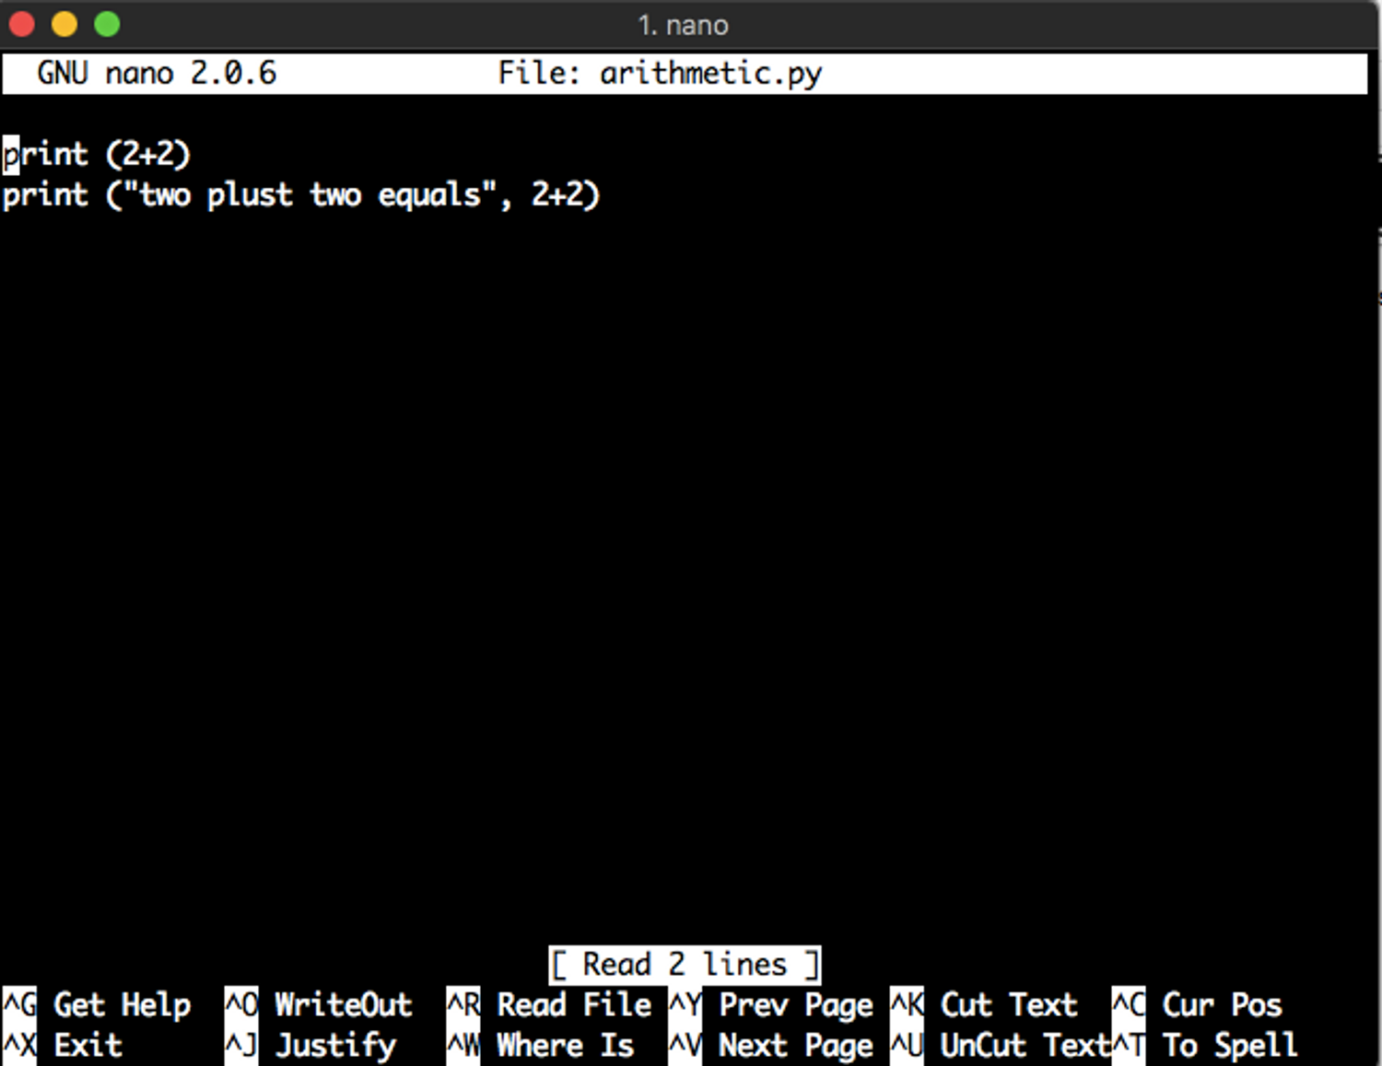

In the above code first 2+2 is added and it will be printed on the screen and in the second line first we are printing the string **two plus two equals** and then we are printing the sum of 2+2.

Save the file with any name as per your choice, for this example, I am using arithmetic.py. Now you need to run your file as we have learned in the previous section. The syntax for running Python file is sudo python3 arithmetic.py

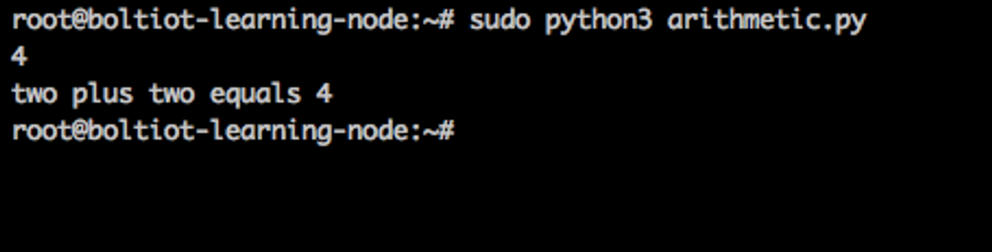

Let us add more examples of the arithmetic operators in our previous file and we will add an example of subtraction, multiplication, and division. Again open the file arithmetic.py in nano and type the code as shown below. To open the previous file, type sudo nano arithmetic.py and write your code inside the file.

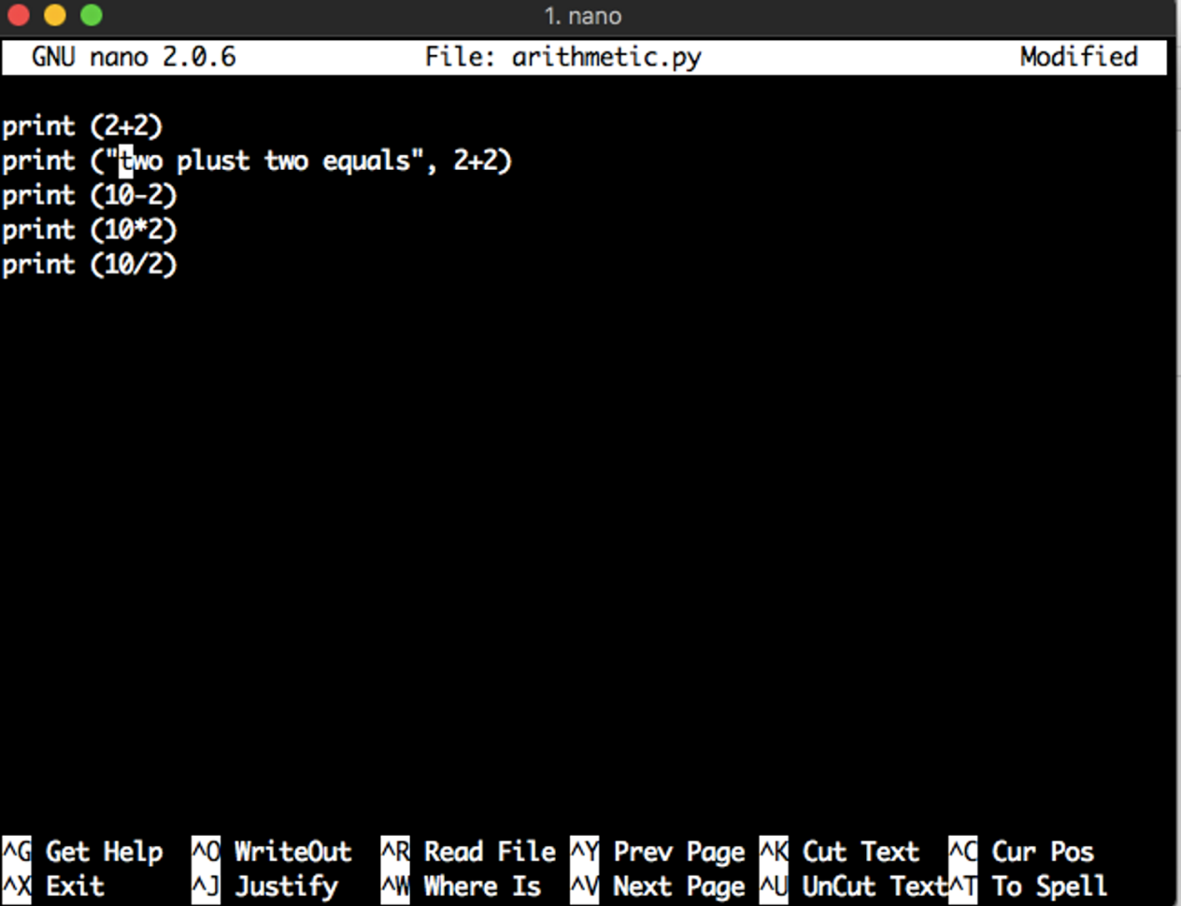

In the third line of the above code, we are subtracting 2 from 10 and printing the result output; In the fourth line, we are multiplying 10 with 2 and in the last line, we are dividing 10 by 2 and printing the result.

Now save the file and run the file to see the output of the program.

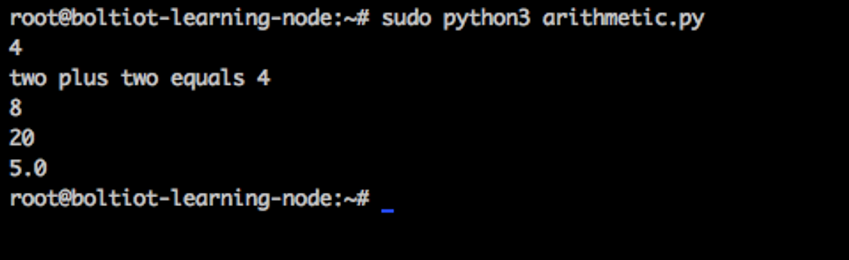

This section covered the basics of arithmetic operators and in the next section, we will learn about variables in Python.